**Asia**

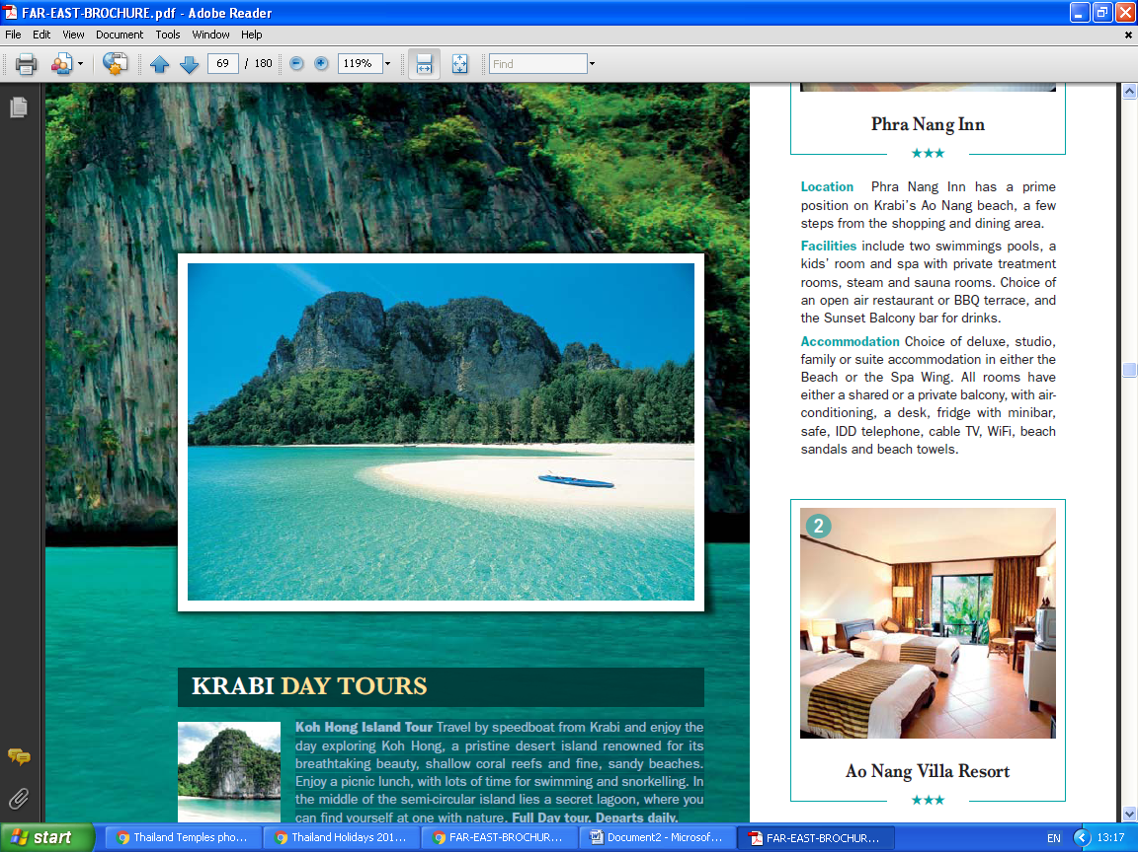4* Bali From £1,099 pp 5* Bangkok From £729 pp 5* Krabi From £889 pp

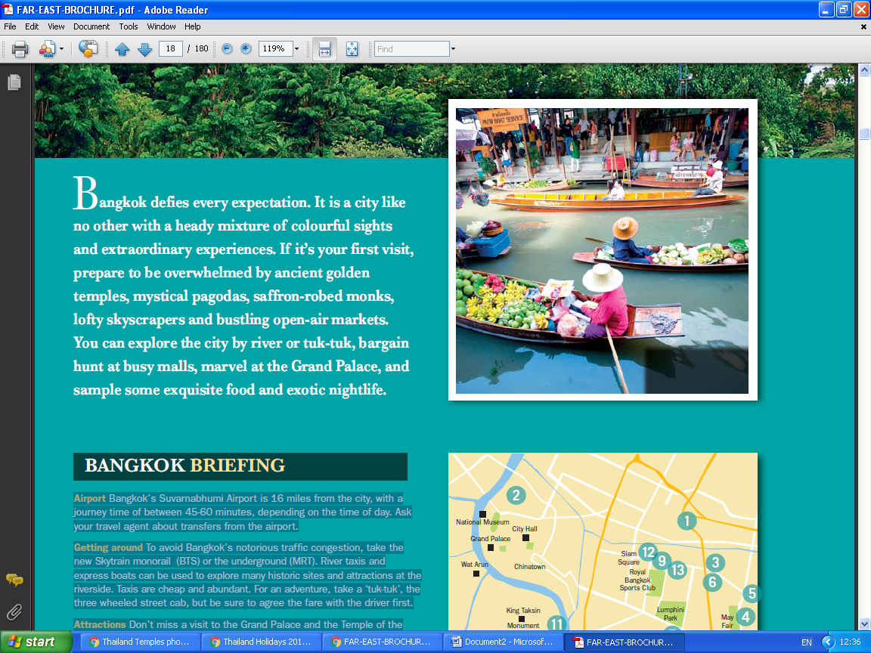

 4* Penang From £629 pp 5* Borneo From £929 pp 5* Vietnam From £999 pp

